**Studii**

Software Requirements Specification

For Study App

**Version 1.0**

**Revision History**

|  |  |  |  |
| --- | --- | --- | --- |
| **Date** | **Version** | **Description** | **Author** |
| 3/21/20 | 1.0 | First phase of the study app through the System Requirement Specification | Lucas Lin  Shazid Rahman Samin Saif |

Table of Contents

1. **Introduction** 3

1.1 Purpose 3

1.2 Scope 3-4

1.3 Definitions, Acronyms, and Abbreviations 4-5

1.4 References 5

1.5 Overview 5

2. **Overall Description** 5

2.1 Use-Case Model Survey 6-7

2.2 Assumptions and Dependencies 7-8

3. **Specific Requirement** 8

3.1 Use-Case Reports 8-10

3.2 Supplementary Requirements 11-12

4. **Supporting Information**  12-13

# **1. Introduction**

This software will be a study application mainly for students to have a better study environment. We will develop a study app that considers all the requirements of students and be as convenient as possible for the users.

**1.1. Purpose**

The purpose of the software is that not everybody is willing or available to meet up with their study-mates. Some students are busy after school and need to work part time to support their families. There are unplanned events going on every day that may force students to miss or late to school. We want to avoid all of these problems by designing a software to help them. This way students don’t have to worry about what they missed in class or be afraid of asking other people.

**1.2. Scope**

**Friend List:** users are able to add friends with their classmates or any study-mates they have.

**Group Chat:** in case users want to work as a group or want to work on the same project, this feature will be very convenient.

**Voice Chat/Video Chat:** not everything can be explained clearly with words and it would be much faster if users can just speak to one another.

**Post:** this feature will be able to show what users posted to their own page. Posts can be files, announcements, or videos. Other study-mates will be able to have access to the shared files. In addition, we want to have tags on each file for an easier, faster and more accurate search. We will have some default tags for example study info, reference, practice problems, solution, and stream record/video. Not just that, we give the user the choice to make their own tags. The reason for this is because there are many subjects that exist, and it is hard to gather all of them by ourselves. We want the users to help us to improve it.

**Calendar:** the purpose of the calendar is to announce all the group members to attend meetings in person. Sometimes face to face conversation is a better way to communicate. This calendar will be able to set reminders, start a vote and show the meeting location on the map.

**Live Stream:** live stream is mainly used for people who are not that well know of each other and provide an emergency plan just in case some members can’t attend a physical meeting. Some side features such as record the stream and share it to either group members or on their personal profile which is public to everyone.

**Share screen/paint board:** for a better visualization

**Library:** we will try to negotiate with the publishers and try to get the usage rights of all kinds of books for teaching. The ordinary users will have to buy the books or rent the books. We will also keep the cost as low as possible.

**Cloud Storage: users can save any files they found on the app to their cloud. Users can view and download the files at any time.**

**VIP Privilege:** Learning is the basic of this app and we will not limit any of the features that are related to learning. We will provide the same features to both ordinary and VIP users, but VIP users will receive more side features that will be convenient for them but not impact the process of learning. In addition, we will try to keep the VIP fee to be as low as possible. This way the app itself will be free but users are more willing to upgrade to VIPs because of the pricing.

* **Cloud Storage:** more cloud storage means users don’t have to worry about where they should save their files.
* **Accessibility of the library:** VIP users will be able to use our library freely
* **System size:** VIP users can invite more people to their system. The capacity can be double or triple the size of ordinary users.

**Super User Privilege:** the super users of a system have the power of all other members weather they are guest, ordinary, or VIP users. Super users can silence other members in chat or voice/video chat. They can kick members who don’t follow the rules.

**1.3. Definitions, Acronyms, and Abbreviations**

User Interface: the means by which the user and a computer system interact, in particular the use of input devices and software.

Live stream: a live transmission of an event over the Internet.

Group chat: a group of people who regularly exchange messages on the internet, especially people who share an interest

User: A real-time communication via keyboard between two or more users on a local network (LAN) or over the Internet. Non-verbal, a computer chat is like sending text messages back and forth.

Case Model: A case modeling is a model which deals with how diverse users communicate with the system in resolving a problem.

Login: an act of logging in to a computer, database, or system.

**1.4. References**

None

**1.5. Overview**

The overview of the design for the entire study app system which we call Studii. This document is meant to detail the functionalities of the system, and how they are carried out as specified in the previous report. This system will introduce the class diagram which will show how the overall system is supposed to function. Detailed functionality will follow later about the system and discussing the user interface.

**2. Overall Description**

Only a new user can sign up, otherwise, they will have to sign in to enter the app. Guest users are not required to sign up to order to join, but they can anytime sign

up and become an ordinary user.

**Exceptional**

The User can input insufficient information or loose connection which will lead to the page not responding or returning an error. If the connection is lost the page should reload the form. If the user puts wrong or insufficient information, they should be asked to input more information or the required information in the correct format. The information is not passed to the database until all the required information is entered and there is a stable connection. A user that has already signed up can log in. They must provide credentials which must match the credentials stored in the database, their existing information must match the one they have entered. Each user is given a unique id that is used by the system to identify the user. The system checks the user’s role database to provide the user with the appropriate options in the User page.

**Exceptional**

The user may provide the wrong credentials, may not have an account, or be a visitor. When the user enters the wrong credentials, the information is passed into the database to check if the user exists. If it does not exist, the user is alerted about their information is incorrect and is suggested to try again. They are also given the option to reset their password if they have lost their password. The user is also given the option to visit the website as a visitor if they happen to be visitors. If the user is not registered, they are given the option to register if they would like, they are then redirected to the registration page.

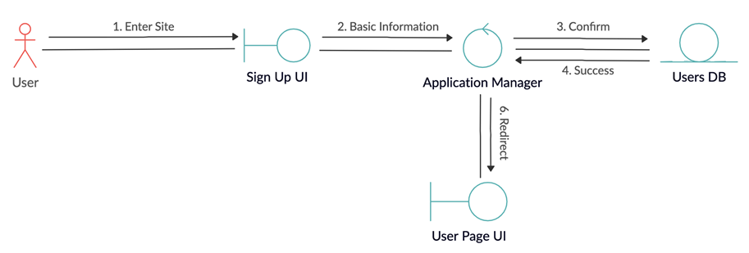**2.1. Use-Case Model Survey**

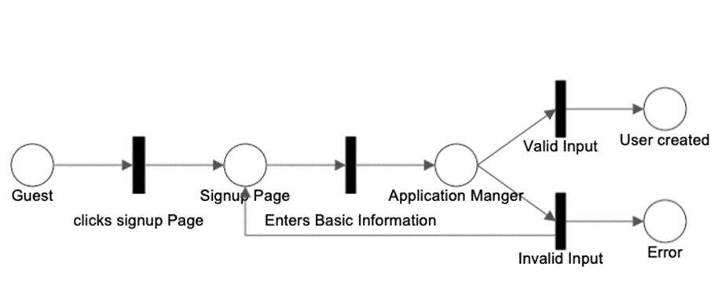Diagram 1. Use-case model for new user entering the app

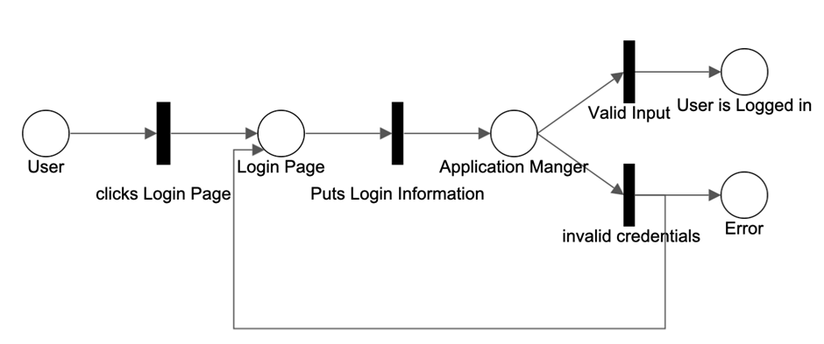Diagram 2. Use- case model for a guest user entering the app

Diagram 3. Use- case model for two cases of an user entering the app. One where its successful and where it fails.

Diagram 4. Use- case model of a successful entry of the app

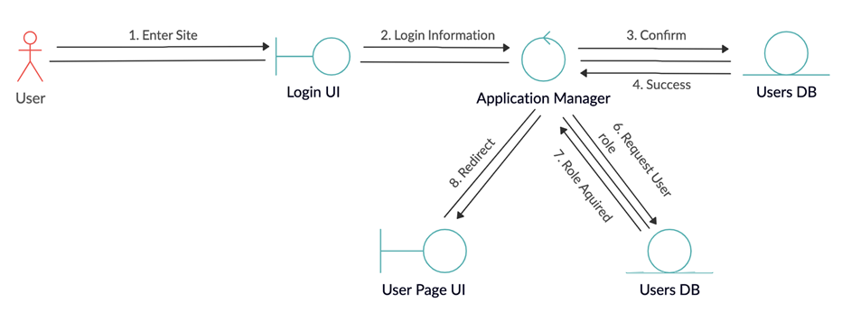

**2.2. Assumptions and Dependencies**

1. There are only two super users, one founding user and another
2. Democratic (voted by other users) .
3. Guest users can’t create groups or be part of any groups.
4. Only super user can approve guest user registration
5. If users have an account, they will not login as guest
6. Users must have positive reputation scores to stay in the system.
7. At Least two members are required to form a group.
8. Only public group posts can be viewed by non-group members.
9. Blocked users cannot login or register again.

**3. Specific Requirements**

**Use-Case Reports**

**3.1.1 Login**

**Description:** User already in the system can login

**Step-by-step:**

1- After app is opened there will be option for login

2- User needs to enter username and password and touch the login button

3- After logging in the user will be automatically redirected to the appropriate page

i.e. Super users will see their home page with all the controls, and ordinary users will have access to regular pages.

**3.1.2 Continue as Guest**

**Description:** Any user who doesn’t have an account can continue as a guest user

**Step-by-Step:**

1.Once a user opens the app, they will have an option button which says continue as a guest.

2. After they touch the option, they will be directed to guest mode of the app where they can view top three projects and surf around to view more projects

**3.1.3 Registration**

**Description:** Registering or signing up new user as ordinary users

**Step-by-Step:**

1. When the guest user opens the app they will see an option to register.

2. After they touch that option it will take them to a new window where they must provide their interest, credential and reference.

3. A Super user will review the application and decide if they will accept the user’s registration.

a. If a register request is rejected the applicant has one more chance to appeal. If the appeal fails, their email address will be saved in the block list forever.

b. If the user is approved the Super user will send an email with account Id and one-time password.

4. When a user log’s in for the first time they would be required to change the password.

**3.1.4 Forming a group**

**Description**: A registered user can form group with other users for collaboration

1. Ordinary user can choose to create a group from the menu options

2. They can invite the other member using their email address.

3. Once all the User replies to invite the group will be formed and a separate page will be created for it.

**3.1.5: Posting in group and messaging:**

**Description:** Group members can post status update

In the group page users can post status from the top corner menu option.

The user will have options to write a text message for updates.

Group messaging is also available on the top next to option dots, a message icon.

**3.1.6 Messaging members**

**Description:** Users can send messages to other users

1. Open the app and go to the home page.

2. An option with envelope symbol will be available in the bottom right corner

3. Touch it and type members email address in the receiver section and message in the text section

**3.1.7 Meeting management calendar**

**Description**: Group members can choose meeting times by voting

1. In the group page there will be a menu option with three dots.

2. Touching it will bring options for the calendar.

3. Members can choose a day a time slot ranges from that calendar.

4. After they touch the done option it will be available as a link in the groups.

5. Other members can touch that link and choose their time and the time slot with max vote will be chosen for meet up.

**3.1.8 Closing a group:**

**Description:** The process for closing a group

1. The users can decide if they want to close a group.

2. There will be on option on the top corner with three dots.

3. Any user can choose the close group option and create a voting

system.

4. Based on the voting system the fate of the group will be decided.

**3.1.9 Making Complains**

**Description:** Visitor or user can make complaint against a group or other users

**Step by Step:**

1. Users or guest users first must go to the main page.

2. Top right corner there will be three dots with option.

3. Touching it will bring an option stating make a complaint

4. Users can choose if they want to complain against a user or group.

a. If user complains against a user, they will provide the users email address

b. If the user complains against a group, they must provide the group’s name.

5. Then the user can write a description, or the reason for his complaints and hit the send option.

**3.1.10: Processing complains**

**Description**: Only the Super User can review the complaints.

1. Super users will find complaints in their inbox.

2. They will review the message and decide on an action.

**3.1.11: Sending compliments**

**Description:** Users can send compliments to other users.

1.The home page of every user has a three-dot option in the corner.

2. After they touch it, it will bring a list, among it they can choose to send a compliment.

3. A new window will appear, with option for email address and text description.

4. There they can send compliments to specific email address with a valid reason by filling in the information and hitting the send option.

**3.2. Supplementary Requirements**

**3.2.1: Types of users**

**Description:** There are four types of users in the app

**Super user (SU):** There can only be two super users who initialize and oversee the system. One super user is the founder of the system, the other one is voted by regular users.

**VIP:** Users whose reputation score exceeds a certain point set by Super user

**Ordinary User (OU):** Self registered users who are approved by super users.

**Visitor:** Guest users, who don’t need to create an account

**3.2.2 Reputation Score**

**Description:** Every user has a certain reputation score that the system uses to

create rankings

When a user opens an account they get the initial reputation score given by the super user.

Super users can deduct and increase reputation points based on other users' complaints and compliments.

An Ordinary user with a reputation score of 30 will be promoted to VIP by the super user.

A VIP with points lower than 25 will be demoted to Ordinary user by the super user.

An Ordinary User with negative reputation score will be automatically kicked out of the system and will be added to the blacklist.

**3.2.3 List of taboo word**

**Description:** The system keeps a list of taboo words. If any individual uses those

words in the chat it will be replaced by *** and the user will lose 1 reputation score. However, if the user uses the same taboo word again they will lose 5 reputation scores.

**3.2.4: Terminated users**

**Description:** Any users who are either kicked out from the system either by the super user or the system will have the chance to login in for the final time and do some processing for the last time. They will be blacklisted with their email address; thus they cannot reopen the account anymore.

**3.2.5: Inbox functions**

**Description:** Users can block other users from texting them. In the three dots option, there is an option for adding users to the block list. User simply must put the specified email address and any text associated with that email address will be blocked.

**4. Supporting Information**

**Entities (Main. Note the rest are in the Diagram and Section 3)**

Users:

Attributes:

username/email

password

first name

last name

Address

user id

VIP/regular (Visitor is an ordinary user ⇒ No Key attribute)

Key: username/email

Managers:

Attributes:

first name

Last name

username

password

user id

Key: username

Classes:

Attributes:

Id

name

address

Key: id

Learning materials:

Attributes:

name

author name

book id

VIP Users:

Attributes:

first name

Last name

username

password

VIP User id

Key: username

Group chat:

Attributes:

first name

Last name

Chat name

password

Group chat id

restrictions

Key: username